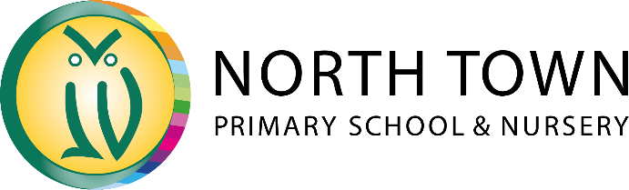


New Pupils’

Parent Handbook

2026-27

Contents

- Our Vision …………………………………………………………………………….. Page 4
- Our Curriculum Intent….……………………………………………………………… Page 5
- Early Years …….……………………………………………………………………… Page 7
- Key Stage 2 …………………………………………………………………………… Page 9
- Statutory Assessments ………………………………………………………………. Page 10
- Term Dates………………………….……………………………………………….… Page 11
- School Uniform ……………………………………………………………………….. Page 12
- Communication with Parents ……………………………………………………….. Page 13
- Wrap Around Care …………...………………………………………………………. Page 14
- School Governors……………………………………………………………………… Page 15
- Pupil Premium Grant …………………………………………………………………. Page 16
- A to Z on North Town ………………..……………………………………………….. Page 17

North Town Primary School and Nursery
Staplegrove Road
Taunton
Somerset
TA1 1DF

School Switchboard: 01823 284676 (School Office Opening Hours – Monday to Friday - 8am to 4pm)
Email: office@nt.huish.education
Website: www.northtownschool.org.uk

Our Vision

North Town Primary School and Nursery is a fun and friendly, multi-cultural and inclusive school. All children receive an excellent education and are proud of their school.

Our ethos allows children to become confident, successful learners in a welcoming, engaging, safe and holistic environment. Children have an excellent learning attitude and are resilient, well-rounded citizens who contribute to all aspects of school life.

Positive relationships are valued across the school community. We believe this should be supportive, trusting, nurturing, open and built on mutual respect where adults lead by example in line with the ethos of the school.

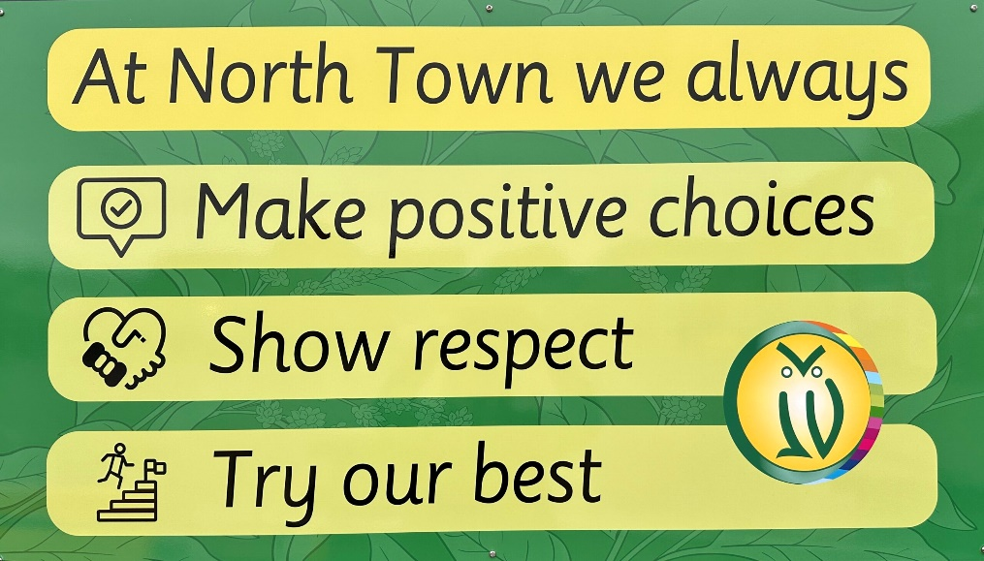

- We promote a broad, balanced and inspiring curriculum that is ambitious for all children. We encourage everyone to develop a lifelong love of learning which provides the opportunity for new experiences and promotes links with our local and global communities.

- Purposeful opportunities are provided for all staff to develop professionally. Training and development are linked to the School Improvement Plan and is valued and prioritised. It promotes the sharing of good practice with other schools in the trust and beyond.

- All members of our school community are valued and work effectively in a positive environment. Work life balance and well-being are placed at the centre of everything that we do.

Our Curriculum Intent

At North Town Primary School and Nursery, we aim to offer all of our children the very best educational experiences possible, recognising that all young people are individuals. We want our curriculum to be exciting, interesting and engaging so that our children are curious, inspired and enjoy learning. We believe it is important that our children experience not only the expectations of legal frameworks such as the Early Years Foundation Stage (EYFS) Framework and National Curriculum but are also given regular opportunities to take their learning beyond this.

Our carefully designed curriculum provides a rich and varied programme of learning experiences and activities to meet the needs, interests and aspirations of all of our children, within and beyond the school day. We have adopted and adapted our curriculum to make sure that it builds on the knowledge our children have already acquired, from the Early Years right through to Year 6, and towards clear end-points that we aim for all of our children to reach. We never intentionally narrow our curriculum or the learning opportunities for any of our children, instead aim to provide a truly broad and balanced curriculum.

Broad in the sense that our curriculum offers all children a wide range of subjects for as long as possible, including a modern foreign language throughout all key stages. Our balanced curriculum makes sure that not only are all subjects taught to all children but are also afforded sufficient space in the timetable to deliver their unique and distinct contribution, enabling our children to try new things and to find and develop their passions and talents. We believe the curriculum we offer should fire children’s imagination and be challenging, yet enable all children to feel success, no matter what their ability or interests. It should promote in children a self-belief and self-confidence and provide opportunities for children to lead.
We encourage active learning through exploration, enquiry, investigation and structured play using first hand experiences wherever possible. We recognise that technology is a part of our children’s natural environment and embrace a wide range of technology as an essential tool for learning. We provide a range of opportunities for children to develop, use and refine key knowledge, understanding and skills, and to practise and apply them regularly in different contexts.

We believe that it is important that our children have a strong awareness of their community and locality, of who they are and where they fit in the world. We aim to take our learning outside whenever we can and make use of areas such as French Weir Park, Longrun Meadow, the town centre of Taunton and beyond. We believe this helps our children to develop a strong awareness of their community and locality, of who they are and where they fit in the world.
We also believe that successful learning depends on a positive partnership between home, school and the wider community and we seek opportunities for our children to become involved in their community and develop partnerships with local businesses and community groups who bring a variety of skills and positive role models to our children.

We actively encourage a variety of independent work, teamwork and collaboration. We use a range of group, class, cohort and whole school learning, and through the selection of creative, motivating, purposeful and relevant approaches to learning, we seek to develop children’s imagination, their openness to possibilities and their ability to reflect critically and question. Our curriculum provides children with a rich and varied learning environment that enables them to try new things and to find and develop their passions and talents. We believe the curriculum we offer should fire children’s imagination and be challenging, yet enable all children to feel success, no matter what their ability or interests. It should promote in children a self-belief and self-confidence and provide opportunities for children to lead. Our curriculum aims to make learning come to life, to engage and inspire, and offer children a love of learning that will last a lifetime.
Our curriculum will give the children the opportunity to:
- see clear links between different aspects of their learning
- develop new skills through a variety of interesting contexts
- experience the challenge and enjoyment of learning
- learn within a coherent and progressive framework
- explore the breadth and depth of the EYFS, including the characteristics of effective learning, and National Curriculum, but be ambitious to go further
- develop and demonstrate their creativity

Knowledge and skills are taught both discretely – in distinct areas – and in a cross curricular way, so that our children gain a broad understanding of each subject, know exactly which subject they are studying, and have an understanding of how their knowledge and skills can be applied in different contexts. The curriculum is designed to embed transferable knowledge and skills throughout, without weakening essential learning.

The outstanding quality of our learning environments serves to stimulate and engage higher order thinking. At North Town, we also recognise the importance of feedback, both adult and peer, as an integral part of the teaching and learning cycle, and aim to maximise the effectiveness of its use in practice. We are mindful also of the research surrounding effective feedback and research from cognitive science regarding the fragility of new learning. In response to this, planning is flexible and responsive to the needs of the children.

Curriculum content

North Town Primary School and Nursery references the objectives of the National Curriclum for England as set out by the Department for Education, combined with our own distinctive approach to ensure learning is tailored to the needs of our children.
You can download details of the frameworks below:

- National Curriculum https://www.gov.uk/government/publications/national-curriculum-in-england-primary-curriculum
- Statutory Framework for the Early Years Foundation Stage
https://assets.publishing.service.gov.uk/government/uploads/system/uploads/attachment_data/file/974907/EYFS_framework_-_March_2021.pdf
- Somerset Agreed Syllabus for Religious Education http://amv.somerset.gov.uk/

Early Years – Reception to Year 2

We believe that every child deserves the best possible start in life and the support that enables them to reach their full potential. Children develop and learn in different ways and at different rates. Within the Early Years at North Town, we have created a curriculum that encompasses our ethos.

Year group of Children | Class Name
Reception Year | New Rock Pippins
Reception Year | Golden Pippins
Year 1 | Kingston Black
Year 1 | Court Royal
Year 2 | Golden Russets
Year 2 | Royal Russets

Pippins
Each child is unique and is valued as an individual; we aim to provide a secure foundation through learning and development opportunities based around the needs of each individual child. All children are given access to the full EYFS curriculum. Through regular assessment and observations, the teachers are informed of the children’s level of learning and their stage of development, providing them with the information they need to decide individual next steps. If it is necessary additional support will be given to ensure children are able to access key learning.

In September, the children will remain in their induction groups (Group 1 or Group 2). These groups will become their registration group and they will be allocated a classroom to register in. Within the Pippins environment we work as a unit with the children getting to know and being taught by all staff, across both classrooms.

During the first half term, teachers will spend time getting to know the children. The children will have opportunities to interact, play with and work with all children across the registration groups. Our main focus for the initial half term is centred around settling into school, exploring the environment, getting to know school routine and building friendships. In October, the class teachers will use their observations of the children to group them into classes. At this point the children will be allocated their class teacher and a classroom. The children will continue to have opportunities to work with all staff and children throughout the year.

Learning through play
In our Early Years classrooms play is paramount to a child’s learning. Each play-based activity is linked to areas of the Early Years Foundation Stage curriculum and is planned carefully to cater for the child’s needs fostering social development, turn taking and sharing. Each area of learning and development must be implemented through planned, purposeful play and through a mix of adult-led and child-initiated activity. Play is essential for children’s development, building their confidence as they learn to explore, to think about problems, and relate to others. Children learn by leading their own play, and by taking part in play which is guided by adults. There is an ongoing judgement to be made by practitioners about the balance between activities led by children, and activities led or guided by adults. Teachers will respond to each child’s emerging needs and interests, guiding their development through warm, positive interaction. As children grow older, and as their development allows, it is expected that the balance will gradually shift towards more activities led by adults, as children become more structured learning. In planning and guiding children’s activities, teachers reflect on the different ways that children learn and respond to these in their practice. Three characteristics of effective teaching and learning are:

• Playing and Exploring - Children investigate and experience things, and ‘have a go’.
• Active Learning - Children concentrate and keep on trying if they encounter difficulties, and enjoy
achievements.
• Creating and Thinking Critically - Children have and develop their own ideas, make links between ideas,
and develop strategies for doing things.

Early Reading

At North Town Primary School and Nursery, we understand the impact reading has on children’s progress across the curriculum and strongly believe that reading is the most important skill that children can master. We are passionate about providing our children with the best start to their academic journey and strive to ensure all children become confident, literate readers and writers. It is our intention that all children develop the key knowledge and skills, which enable them to enjoy a variety of books and access information independently.
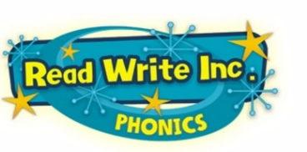
Phonics provides the foundations of learning to make the development into fluent reading and writing easier. At North Town Primary School and Nursery, we follow the Read Write Inc phonics programme. Read Write Inc (RWI) is a consistent, rigorous and dynamic literacy programme to teach EVERY child to read. The children learn to read and write fluently so that they can focus on developing their skills in comprehension, vocabulary and spelling. Through RWI phonics children learn a simple alphabetic code followed by a more complex code. The children are assessed and grouped for phonics according to their sound knowledge and their ability to apply this knowledge to decode words. This enables us to focus on each child’s next steps to progress their reading. All reading books progress cumulatively, matched to the sounds children are learning and already know. The approach is systematic and is carefully structured into phases – Set 1, Set 2 and Set 3.


As the children complete Read, Write Inc Phonics they will continue their reading journey, through carefully planned guided reading lessons and the use of the Accelerated Reader program. These aim to continue building the children’s fluency and develop their comprehension.

Key Stage 2 – Years 3 to 6

Building on the foundations of the Early Years, as the children enter Key Stage 2 we continue to help them grow as unique and individual young people, ensuring they become responsible, lifelong learners and confident citizens of the future. We want our children to be seen by others as role models for our school who possess the life skills of independence, resilience and curiosity which will enable them to not only be successful as they move throughout their education but also in later life. We want to encourage children to recognise the importance of duty and showing respect to themselves, others and their community. Throughout Key Stage 2, the children are encouraged to take responsibility for their learning and are challenged each day through a wide range of engaging and exciting learning experiences both in and out of the classroom. Whether it is the core curriculum learning areas such as reading, writing and mathematics or overnight residential trips to activity centres such as Charter House, the children in Key Stage 2 are provided with a broad, balanced and inspiring curriculum in which they will thrive. Their education will be led and fostered by a team of inspirational, knowledgeable and dedicated teachers who will make the most of every learning opportunity to encourage curiosity, imagination and collaboration alongside the children.

As the children progress through the key stage, a strong significance is also placed on nurturing independent learning skills, such as resilience, perseverance and initiative. Through regular and robust assessment, our teachers know the strengths and areas of development of each and every child. Regular opportunities, however, are also provided which allow the children in Key Stage 2 to have choices in their learning, where they will develop an appreciation of the importance of challenge, self-reflection and risk taking to achieve their individual goals and potential as a learner.

Within the classroom, the children will be engaged in their learning through a carefully selected termly project designed specifically to cater for their interests and needs. They will be immersed into their project through a cross-curricular approach, which allows them to not only acquire new and relevant learning but also develops key skills such as reading and writing. We believe that through this approach, our children will develop a real purpose for their learning. During Key Stage 2, our children will become confident and capable readers, writers, mathematicians, scientists, historians, geographers and much, much more. Our skilled and committed teachers work closely with the School’s SENDCo and other professionals to support the needs of all children and ensure equal and inspiring opportunities are provided for all.

Both inside and outside of the classroom, the children in Key Stage 2 are entrusted with ample opportunities to be positive role models, through popular and rewarding experiences such as School Councillors, Playground Leaders and Junior Librarians. Such roles carry high expectations and come with great responsibility, which is a theme that plays a central part in all of the children’s lives in Key Stage 2 and is continually fostered by all staff.

Throughout Key Stage 2, a further importance is placed on the children creating, developing and maintaining positive relationships will all whom they meet. We encourage the children to care and respect each other, to follow the teachers’ examples of acting as role models who demonstrate a sense of duty, to value and respect all cultures, beliefs and religions and to act politely and respectfully within the school environment, local community and beyond. Furthermore, we recognise that positive and professional relationships with parents and carers are crucial in continuing to provide the very best for our children. There are formal opportunities to discuss the achievements and well-being of the children each term in private one-to-one meetings with their class teacher, whilst more informal discussions are also welcomed to help best support the children.

Statutory Tests/Assessments

During the summer term, the following statutory tests will be taking place:

Early Years Foundation Stage Assessments (Reception Year) – Reception Baseline Assessment completed in the initial weeks of school. EYFS Profile finalised in the last week in June.
Phonics Check Tests (Year 1 children and some Year 2 children if they need to retake the check) – Usually the second week in June.
Multiplication Tables Check (MTC) (Year 4) – Usually the first 2 weeks of June.
Year 6 SATs – Usually the second week in May

It is very important that the children attend school during the above dates and any term time absence requests will not be authorised.

Early Years Foundation Stage Assessments – Reception Year
Assessments are carried out throughout the year and we complete the Reception Baseline Assessment on the children’s entry to school and report against the Early Learning Goals from the Early Years Foundation Stage Profile to the Local Authority at the end of June.

Year 1 and some Year 2 children Phonics Check Tests
All children in Year 1 will complete the Phonics Check Assessment which tests the children’s phonics skills. A pass mark is set each year after the tests are taken. If your child attains the pass mark they do not have to take the test again. If your child does not meet the pass mark, they are required to take the test a year later when they are in Year 2. The tests take place in June.

Year 1 to Year 5 (non-statutory)
To ensure the children are resilient and prepared for future tests, children in Key Stage 2 have termly tests in Reading, Mathematics and Spelling, Punctuation and Grammar. The tests are to inform the teachers of how the children are doing generally and also in specific areas, so the teachers can plan accordingly for the next term. They are designed for the children to ‘show off’ their abilities, rather than pressure them for grades. Key Stage 1 children will have a go at tests appropriate to their age and stage of development.

Multiplication Tables Check (MTC)
The multiplication tables check is statutory for all year 4 pupils.
The purpose of the MTC is to determine whether pupils can recall their times tables fluently, which is essential for future success in mathematics. It will help schools to identify pupils who have not yet mastered their times tables, so that additional support can be provided.
Year 6 SATs (Statutory Assessment Tests)
Children in Year 6 are required to take Year 6 SATs. The test week is usually the second full week in May. The tests are: Mathematics, Reading and GPS (Grammar, Punctuation and Spelling). The tests are externally marked and the test results are reported in July. Writing Assessments are made through the children’s class work and reported on as well.

Term Dates & School Times

School Timings

The school gates are opened by a members of staff at 8:40am. Parents and carers can access the school at the front gate on Staplegrove Road and the back gate on Upper Wood Street. The gates are closed at 8:50am. Any late arrivals must press the intercom through to the school office and they will open the school gate.

The school day finishes at 3:15pm. The back gate will be opened by members of staff for parents to collect their children.

September 2026 to July 2027

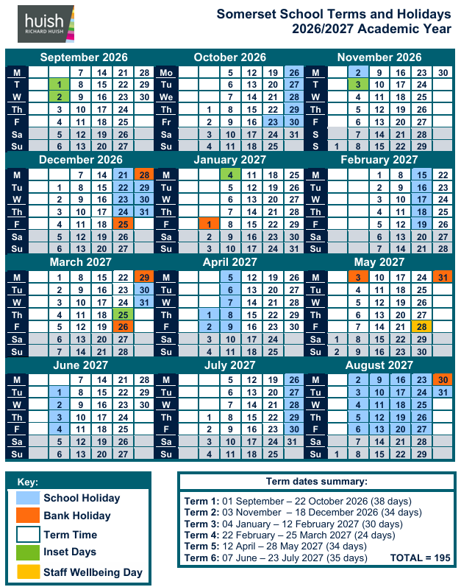

School Uniform

North Town Primary School has a unisex uniform list, so please choose whichever items from this list you feel would best suit your child. Both girls and boys are required to wear a tie, as we feel this will promote equality and pride in the school identity.

Items that marked with * are available at South West Schoolwear Shop on East Reach but all others should be easily sourced in numerous other outlets. Uniform can be purchased online from South West Schoolwear. https://www.swschoolwear.co.uk/shop/pcategory/schoolwear/north-town-primary/
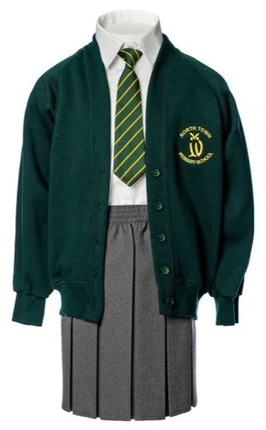
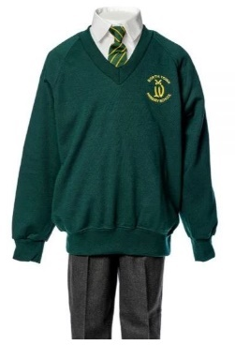
North Town School Uniform
Logo sweatshirt or cardigan*
White shirt (NOT polo shirt)
Tie*
Grey trousers/skirt/pinafore/shorts
Grey, black or white socks
Grey or green tights
Black shoes (No boots, pumps or trainers)

Warm Weather Options (Between April and October at parents’ discretion)
Green & white gingham dress
Grey shorts
White short sleeved shirt (NOT polo shirts)
No tie in warm weather at the discretion of the Head/Senior Leadership
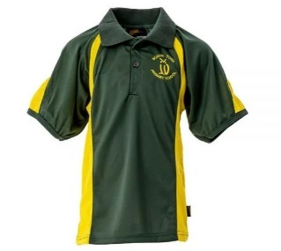
PE Uniform
Green and yellow sports shirt*
Black shorts or skirt
Winter tracksuit trousers (plain unbranded black)
North Town hooded sweatshirt*
Black or white sport socks
Black or white trainers

We provide special uniforms for official school team matches. However, as the school frequently participate in a wide range of interschool events, we ask that all pupils adhere to the official PE uniform.

Hair ties and accessories should be green, grey, white or black.
Jewellery other than plain ear studs, make up, and temporary tattoos are not permitted.

ALL uniform items must be clearly labelled with your child’s full name.

Communication with parents/carers

We strive to create and maintain a partnership with parents and carers, encouraging parents to talk to their child’s teacher if there are any concerns. There is a formal meeting for parents each term at which the teacher and the parent discuss the child’s progress. This discussion will explore the child’s readiness to learn and how best support their needs.



ClassDojo is an online learning platform that supports our partnership between home and school. It is used as a communication tool for teachers to share with parents/carers the exciting activities and learning taking place in the classrooms. Children can earn Dojo points which are linked to key classroom values. Using this simple program enables parents to share in their child’s successes at school whether this is a Dojo point for working collaboratively with peers, a standout piece of work or photos from an external visit experiencing something new.

Teachers also use Class Dojo to share observations of the children’s learning with parents/carers. As the children develop their skill in the classroom, teachers empower the children to record their own learning in class in a variety of ways using photos, videos, drawings or text.


My Child At School (MCAS) is an online portal for parents/carers that enables you to view and book school lunches, parents evenings and wrap around. The app makes payments quick and easy with all payments to school, including school trips, made through this App.

North Town Wrap Around Care

North Town Wraparound is our breakfast and after school club based at North Town school, and run exclusively for children attending the school.
Our aim is to create a fun and safe ‘home away from home’ environment where your child is happy to begin and end their school day, we have a variety of activities that your child can participate in, whether they want to burn off some of their boundless energy or just relax.
For parents, we aim to provide a valuable service that is flexible, reliable and cost effective.
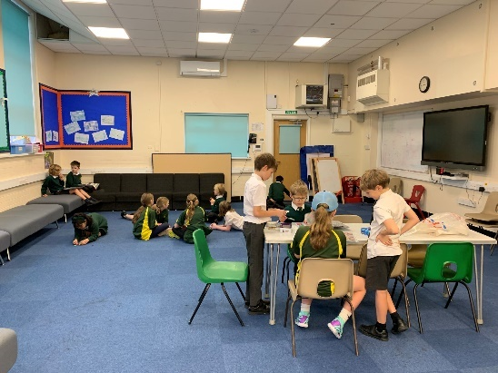
We strive to create a very relaxed atmosphere where children are able to choose for themselves what activities they wish to participate in, such as:
- PlayStation 3 and Nintendo Wii with various games,
- iPads,
- Television and a wide range of films,
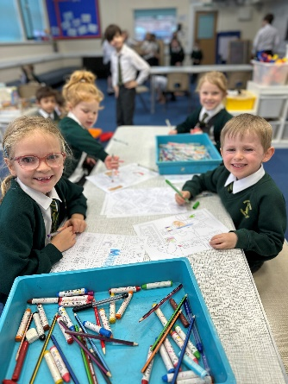
- Jigsaws, board games
- Barbie, Action Man, play animals etc.,
- Lego, K-NEX, cars
- Outdoor play equipment,
- Dressing up clothes,
- Information and story books,
- Musical Instruments,
- Supervised art and craft activities.

To contact North Town Wraparound please call 07566 733010 – please use the email address for payment/booking enquiries: wraparound@nt.huish.education

Booking Wraparound Sessions
In order to book wraparound sessions you will need to download the ‘My Child at School App’, shown below:
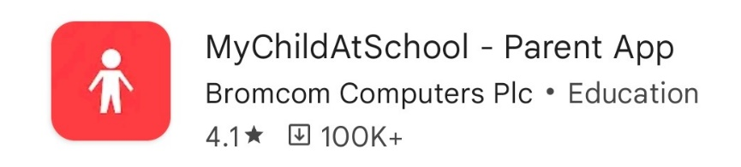
The school will provide registration details for you to set up a user account and provide instruction for how to book.

School Governors
School governors are volunteers who play an important part in setting the direction of the school, helping us to continually raise standards.
At North Town Primary School, our governors offer us an excellent balance between 'critical friends' and managers of our decision-making process - each of whom is passionate about improving the lives of our children.
Governors at the school have been heavily involved in a number of important aspects of our development including our school monitoring programme, attendance issues, teaching and learning, curriculum development, staffing and staffing structures.
For more information regarding Governors and the role they play please visit: www.nga.org.uk/Be-a-Governor/Be-a-Governor.aspx
For this academic year (2026 / 2027) our Board of Governors are made up of:

Governors
Mr Philip Jones (Chair)
Mr Derek Perry (Vice Chair)
Mr Mathew Nolan
Mrs Ellie Green
Mrs Joanna Gavins
Mrs Jessica Smith
Miss Phoebe Causley
Miss Jessica Fairfax

Head Teacher & Accounting Officer
Mr Matt Kerton
School Business Manager & Chief Financial Officer
Mr Paul Lonsdale

Pupil Premium Grant

What is Pupil Premium?
The Pupil Premium is an additional grant allocated to all schools by the Government to support the raising of attainment of pupils eligible for free school meals. The Government has given the school the freedom to spend the grant in the way that it thinks will best support the raising of attainment of pupils’ eligible for free school meals and to choose the areas where it will have the most impact. At North Town School, we aim to ensure that pupils who are eligible for free school meals perform to the best of their ability and make as much progress as their peers. The school uses Pupil Premium funds to ensure that these pupils are motivated to succeed, are engaged in their learning, develop a positive self-esteem and develop the skills necessary to achieve academic success.

In common with most schools it is likely that a number of parents/carers whose children attend North Town do not claim free school meals, even though they are entitled to them. By registering your eligibility, you can also choose to access a range of daily lunch options for free (although there is no requirement to do so). If your child is currently in Reception, Year One or Year 2, they are eligible for Universal Infant Free School Meals, however, please do still apply for Free School Meals if you believe you are eligible as this will mean that the school is able to access additional funding in the form of the Pupil Premium Grant which will be used to support your child academically.

How do I know if my child is eligible for the Pupil Premium?
The Pupil Premium Grant and Free School Meals are available to children whose parents / carers qualify by meeting the criteria listed below:
- Universal Credit
- Income Support (IS)
- Employment and Support Allowance (Income Related) - not Contribution related
- Income-based Job Seekers Allowance (IBJSA) - not Contribution based
- Guaranteed Element of State Pension Credit.
- Support under Part VI of the Immigration and Asylum Act 1999
- Child Tax Credit with an annual taxable income (as assessed by HMRC) of less than £16,190 as long as the family are not also in receipt of Working Tax Credit.
Similarly, the school to access the Pupil Premium Grant for the following:

- Children of service personnel;
- Children who have been adopted from care or who have left local-authority care because of adoption;
- Children under a special guardianship order, a child arrangements order or a residence order;
parents and carers need to make the school aware of their status.
If you think that you may be eligible to apply for free school meals for your child, you can do so using this link www.somerset.gov.uk/freeschoolmeals, alternatively contact the school office for more information. The process for applying is confidential. Even if you are not sure it would still be worth asking.
We fully appreciate that information may be sensitive and can assure you that all information will be handled in the strictest confidence.

A – Z of North Town Primary School and Nursery

A is for …..
Absence through illness
If your child is unwell and not able to attend school, please ring 01823 284676 and leave a message detailing your child’s name, class and reason for illness. It is really important that we know what illness your child has, as it could have an impact on other children or staff. Please ring the school and update us every day that your child is absent from school.

Absence medical/dental appointments
We discourage medical/dental appointments during school hours, as they can be arranged after school or in the holidays. However, we appreciate that there are times when this cannot be avoided. In order to be able to authorise an absence for a doctor/dentist or hospital appointment, we do require a copy of the appointment card/letter. Please provide this to the school office in advance of the appointment. We may also request a term-time absence form to be completed. Please also make the class teacher aware of the date and time of the absence.

Arrival at school
The gates will be opened by a member of the SLT at 8.40am each morning. The children can then be taken straight to their classroom.

Arrival at school - Late arrivals
If you arrive after the start of the school day, please report to the school office to ensure your child is registered. You will need to use the Staplegrove Road entrance and buzz the intercom and speak to the School Office staff.

Attendance
Regular attendance at school underpins success in all areas of the curriculum. All pupils should achieve at least 95% attendance, with the aim of 100%. Please also refer to our Attendance Policy.

B is for …..
Bikes and Scooters
As a healthy school, we encourage our children to cycle or scoot to school. Our bicycle and scooter racks are located just inside the school gates at the front and back of the school. Children must walk their bike or scooter whilst on the school site.

C is for …..
ClassDojo
ClassDojo is a simple and convenient online learning platform, used to communicate, collaborate, celebrate and share information between home and school.

Clubs
The school offers a variety of clubs during lunchtimes and after school. Information is sent home on a regular basis informing parents of clubs available on a termly basis. These vary from: Sports to Choir. We offer a variety of Sports Clubs including, football, netball, cricket, gymnastics and many more. These are led by school staff as well as being provided by external coaching companies such as GRV Coaching. All coaches are DBS checked with first aid qualifications.

Consent Forms
As part of the admission procedures, parents/carers are required to complete a number of consent forms after reading the appropriate policies:
- Pupil Images Policy/Consent Form
- Off Site Policy/Consent Form
- Acceptable Use Policy/Consent Form
- GDPR (General Data Protection Regulation) Privacy Notice – Pupils and their Families/Consent Form
- Collection Policy/Consent if allowing child to leave school site alone.
- Home School Agreement

Curriculum Overviews
Each term, the Curriculum Overview will be sent home to let you know what your child will be learning at school and the project-based homework for that term. The overarching theme will be either Science, Humanities or The Arts.

D is for …..
DBS (Disclosure and Baring Service) Check
All staff and visitors have to have a DBS (Disclosure and Baring Service) check before being employed or visiting/volunteering at school.

Dietary Requirements
It is vital that your child’s dietary information is kept up to date. Please inform us of any dietary requirements.

Dressing
The children come into school in their PE kits on their PE days, however it is still important the children learn independent dressing skills. The most important skills for your child to learn are:

- To put on and take off their jumper.
- To put on and take off their coat. When they are able to do this they can begin to learn to zip up their own coat.
- Skirt/trousers/shorts, socks/tights and shoes – In case they need to change these during their time at school.

Please pack some spare underwear, socks/tights in your child’s bag – In case of toileting accidents or water play.

E is for …..
Education Health and Care Plan (EHCP)
The EHC Plan is a document which replaces Statement of SEND and Learning Difficulties Assessments for children and young people with special education needs.

Early Help Assessment
This is an assessment which captures a child/family’s needs at the earliest opportunity should additional support agencies need to help with a family’s situation.

Eating
We operate a healthy lunchbox policy, if bringing a packed lunch from home. Children are not allowed to bring fizzy drinks, sweets or bars of chocolate. If your child has a school dinner, they will eat from a plate and use a knife, fork and spoon, so for our very youngest children, it would be helpful if they know how to use these before they start school.

Extreme Weather Procedures
In the winter months bad weather is a possibility; these are the procedures, should it be necessary to make the decision to close the school. Closure of the school would only be made in extreme weather conditions and where the majority of staff are unable to attend. Of course, every effort would be made to ensure the school is kept open. However, in the event that the weather deteriorates significantly and in the event that we experience heavy snowfall/flooding, please check the following:

• School website – www.northtownschool.org.uk
• Your mobile for a text message/e-mail via PMX Parentmail
• BBC Somerset (95.5 FM) - http://www.bbc.co.uk/bbcsomerset
• Heart FM (96.5/102.6 FM) - www.heart.co.uk
• Tone FM (107.8 FM) – www.tonefm.co.uk
F is for …..

Free School Meals
Free school meals are available to children whose parents qualify by meeting certain criteria. Further information can be obtained from the school office. It would really help us if you could ensure you complete an application form for Universal Free School Meals when your child joins us, even if you do not believe you will be entitled. This is different to the free meals available for children in Reception, Year 1, Year 2.

Fruit
We encourage children to bring in a piece of fruit to eat at afternoon snack time. Children in the Early Years classes will also enjoy a fruit snack in the morning which is provided by the school.

G is for …..
Going Home Arrangements
If you would like to change the current permission arrangements in place for the collection of your child, please complete the slip at the bottom of our Collection Policy and return it to the school office. A copy of this is available from the letter rack outside the school office and is printed on yellow paper. Please note – children are not allowed to leave the school site without the permission slip completed by the parent/carer and given to the school.

If you are going to be late collecting your child, please ring the school office and let us know, so we can inform your child’s teacher.

If for any reason, somebody different is collecting your child, you must provide us with the full name of the adult collecting your child. If we do not have their name on our list we will not release your child to them.

H is for …..
Hair
Hair longer than shoulder length must be tied back. This applies to boys and girls. Hair ties and accessories should be green, grey, while or black.

Homework
Homework is anything that children do outside the normal school day that contributes to their learning following guidance from the school. We believe that homework should promote a positive link between home and school. Through homework children can see first-hand home and school working towards common and shared aims in their education. Homework encompasses a whole variety of activities instigated by teachers and parents to support children’s learning.

Children receive homework throughout their time at North Town. There are various types of homework that we set:
- Ongoing homework that allows children to rehearse key skills on a repetitive basis for short periods of time, such as consolidating sounds learnt in phonics and reading.
- Project based homework that prepares children for forthcoming activities in class that may take longer to complete,
- Project based homework that expands upon activities in class.

Mental Maths
Developing fluency in key number facts supports children to build the foundation for mental calculations. Children will begin to access Numbots in Reception and through key stage 1. When they are ready the children will move into Times Table Rockstars. These are online platforms which offer timed games, supporting the children to build fluency through fun practice.

Reading
All children will bring home a reading book that is matched to their individual reading level. In Early Years and Key Stage 1 the children are assessed and grouped through the Read, Write Inc program to ensure they are reading books which match their sound knowledge. The children will bring home a copy of the book they have been reading in their RWI lessons to improve their fluency skills. They will also bring home a ‘Book Bag Book’ the same level as the book they are reading in class but one they have not read before.
When the children have completed Read, Write Inc they will continue to develop their skills through Accelerated Reader. This is an online reading program where the children complete quizzes linked to the text they are reading which supports and assesses their comprehension skills. Children also have the opportunity to borrow a school library book. We encourage children to choose a book they are interested in which may mean they require support when sharing the book at home. It is important to remember that reading is not simply about decoding the words in a book. A dialogue about the text and the characters is equally, if not more, beneficial to a child’s reading development. We also actively encourage parents to make use of local library facilities to expand their child’s engagement in reading. Our school expectation for reading is at least 5 times a week. Reading has huge benefits to your child’s learning across the curriculum and beyond.

Sound and Word bags
Children in Early Years classes will have sound and word bags. Parents should support their child with learning the sounds and reading the words in their bags alongside reading books.

Early Years
Early Years classes will receive one piece of project-based homework per half term. The homework activity, and the date that it is due to be completed by, will be introduced on the curriculum letter that is sent home at the beginning of each topic.

Home School Agreement
You will be given a Home School Agreement which is a document which you should share with your child. The document defines what we expect the pupil/child to agree to whilst at school, what we as a school will do and what we expect parents/carers to undertake. This document should be signed by the child and parent and returned to school to demonstrate everyone’s agreement.

I is for …..
Inhalers
If your child requires an inhaler - no matter how mild their condition is - we require an inhaler to be in school at all times. If this applies to your child, please would you complete the necessary medical consent forms obtainable from the school office and give the completed form and inhaler to your child’s class teacher who will store the medication in school for the remainder of the year. The medication can then be taken out of school when the children attend school visits.
J is for …..

Jewellery
No Jewellery is permitted other than plain ear studs.

K is for …..
Kitchen
We cook all our school lunches freshly on site in our purpose built kitchen.

L is for …..
Lost Property
We accumulate a lot of lost property, mostly unnamed. Please ensure you clearly name ALL items of your child’s school uniform. If found, they will be returned to them. Our Lost Property is located in the foyer opposite the school office.

Lunch Menus
Our Catering Team, in consultation with our School Council, create mouth-watering menu choices each term. Menus are sent home to parents via MCAS. To ensure your child receives a meal, a fully completed menu must be completed online. If your child is in Reception, Year 1 or Year 2, they will qualify for a Free School Meal. No money is required, but a menu must be completed online using MCAS. If your child is in Year 3, 4, 5 or 6, you will need to top up your MCAS dinner money account so you can order and pay for lunches. If you are entitled to receive a free school meal (pupil premium), no payment is necessary. If you have any feedback for the kitchen, they would love to hear from you. You can contact our catering team by email: kitchen@nt.huish.education.

M is for …..
MCAS – My Child At School
MCAS is the school to home communication system used at North Town Primary School to keep parents/ carers regularly informed about what’s going on at the school. The school are able to send messages to parents/carers reliably and share important or urgent information. Parents using the MCAS App are able to view and book parent’s evenings, school lunches and wraparound. MCAS is used to make all payments to school, including school trips.

Medicines
If your child is prescribed medication which needs to be administered in school, a Medicine Consent Form needs to be fully completed, signed and given to the office. The forms can be obtained from the school office.

Milk
Free milk is available for all children aged under five in school, funded by the government. At North Town, we continue to provide milk even after the child’s 5th birthday for free in their first year at school. In our school, this milk is supplied by Cool Milk, the UK’s leading school milk supplier.

Mobile Phones
Mobile phones are strictly forbidden in school. Your child may bring a mobile phone with them to school, however it must be handed to the Class Teacher for safe keeping during the school day and your child can collect their mobile phone after school.

Musical Instrument Lessons
Music teachers from Taunton Music Centre come to school to teach a variety of different musical instrument lessons. Instrumental lessons such as keyboard, piano and string lessons are available.

N is for …..

Newsletters
A weekly Newsletter is sent home on a Friday. This is a useful way of catching up on events that have happened in the school and also news of what is coming up.

Nursery
Since September 2016, North Town has its own thriving Nursery for children aged 2 to 4 years old on the school site.

O is for …..
Ofsted
Our last Ofsted Inspection was in March 2023, where we were graded as “Good”. Please visit our website for the full report.

Online Safety
North Town Primary School and Nursery recognises that Information and Communication Technologies and the Internet are fantastic tools for learning and communication that enhance the curriculum and support creativity and independence. Using technology to interact socially and share ideas can benefit everyone in the school community, however it is important that technology is used safely and responsibly and as such online safety is an important part of the children’s education and is embedded in their learning at school. Please visit our school website for important information and advice about staying safe online.

P is for …..
Packed Lunches
If your child would prefer to bring a packed lunch instead of a school meal, they must bring a ‘healthy’ packed lunch in a suitable lunch bag/box. There are designated lunch bag/box trollies for each year group. Chocolate bars and fizzy drinks are strictly forbidden.

Parents’ Evenings
Parents’ Evenings are held in the autumn and spring term and are a valuable opportunity to discuss your child’s learning and progress with their class teacher/s. Appointment bookings can be made via MCAS. The booking system goes live a few weeks prior to the evening. We hold two Parents’ Evenings per term, from 3.30pm and 6.15pm. If your child has additional educational needs and has involvement from) our SENDCo (Special Education Needs Co-ordinator), you will be notified of a different date to meet with her.

Parking
Parking is limited in the surrounding areas of our school site. When dropping off or collecting your child from school, please consider our neighbours and park your vehicle in the designated ‘on road’ parking area or a local car park. Please do not park in the resident parking zones. Parking Enforcement Officers make regular visits to the local area and parking tickets are issued to offending vehicles. Wood street car park offers 20 minutes free parking.

Pen Licence
All children write with a pencil until they have earned their Pen Licence. Children earn a Pen Licence when they form all letters correctly, join all letters, correctly orientate ascenders and descenders, have lower case letters of uniform height. When a child earns their Pen Licence, they may write using a blue pen (roller ball style, not biro). All mathematics work is written in pencil.

Pencil Cases
Children are not allowed to bring pencil cases into school. The school provides pencils and pens as well as anything else that the children need to use for their learning.

Playground Leaders
Playground Leaders encourage all children to take part in play activities and ensure the smooth running of lunchtimes for everyone.

PTA
The PTA are best known for fundraising work but also have a social function too. Fundraising events provide an opportunity for us all to get together and have fun. The money that is raised by the PTA is intended to provide the 'extras' not already provided in the school's normal budget. Often the fun things make learning more interesting and exciting.
We regularly run fundraising events such as discos for the children, Christmas Fair, Summer Fair, Quiz. We also have a clothing and textile bin situated near the school gate on Staplegrove Road. The contents of this are collected regularly and this raises funds for the school but also supports a local charity.
In recent years, the PTA has contributed towards:
- the Pirate Ship,
- the MUGA (Multi Use Games Area),
- 'wet play' toys for all classes so they have toys and games to use in the event of poor weather, and
- books for our library
- two new table tennis tables
- play equipment and resources for the playground.

We are always looking for new ideas and people to help run events and really appreciate any support you are able to offer. We have a small team of people who work hard towards making these things happen so we would love new members to come along! If you are interested in joining our PTA, please send an email into the school office.

Photographs
During the autumn term, professional photographers come into school to take individual portrait and sibling photos which parents can purchase. They also take Year 6 Leaver photographs in the summer term. Periodically, we arrange a whole school photograph.

Pupil Premium Grant
The Pupil Premium is an additional grant allocated to all schools by the Government to support the raising of attainment of pupils eligible for free school meals. The Pupil Premium was introduced in April 2011 and is allocated to schools to work with pupils who have been registered as eligible for universal free school meals at any point in the last six years. Schools also receive funding for Looked After Children, children adopted from care and children of service personnel. For further information, please see page 17.

Q is for …..
Questions
Your child should never be afraid to ask questions. It is good to have an enquiring mind.

R is for …..
Reports
Your child’s End of Year Report will be emailed home in July. For environmental reasons, we do not produce paper copies.

Residential Visits
The children in Year 6 have the opportunity to attend a residential visit to the Charterhouse Centre in the Mendips where they experience a range of outdoor and teambuilding activities. See https://www.sseoutdoors.co.uk/. The residential normally takes place during the Autumn Term of Year 6.

S is for …..

School Council
Our School Council is elected to represent our children at leadership level and ensure a “voice” for all children. We encourage our children to take a full and active role in the life and development of the school. They express children’s views to the school’s leadership and work particularly closely with staff on playground issues. The school council meets regularly with our Wellbeing Leader to discuss school improvement ideas and fundraising events.

School visits/visitors
We provide a very varied and experiential curriculum, and like to take the children our on visits or invite visitors into school. This way, the children gain valuable first hand experiences which then have a big impact in their work in the classroom as well as gaining memories for life.

Sing Song
Our Key Stage 2 children perform a Christmas play at our Key Stage 2 Christmas Service which is held at St James’ Church normally on the last day of the autumn term. In EYFS, Year 1 and Year 2, the children perform a Christmas sing song where parents/carers, family and friends are invited to watch.


Speech and Language Therapist
Our Speech and Language Therapist – Claire Morris, works in school reguarly. Claire supports those children identified with low level speech, language and communication difficulties to ensure their continued progress. Referrals are usually made by the teacher and SENDCo, in consultation with the parent/carer. More significant needs are referred to the NHS Speech and Language Therapist as normal and Claire supports this process through liaison and staff training.

Sports Days
Our Sports Days are held in the summer term, usually in June/July.

Staff Car Park
The car park on the school site is for staff and visitors only and is locked at all times. For health and safety reasons, please do not enter the car park at any time.

Sun Cream & Sun Hats
During the summer/autumn terms when we experience warm weather, please apply sun cream to your child before they come to school and provide your child with a cap/sun hat to wear as we like to take our learning outside of the classroom. Please ensure the cap/sun hat is clearly named. Sun glasses are not permitted unless for medical purposes.

Sweets and Cakes
We cannot hand out sweets and cakes if it is your child’s birthday. This is because the Governors felt strongly that it was putting undue pressure on those parents who cannot or do not wish to provide cakes etc for their child’s birthday. In addition, the distribution of these cakes and sweets can take as much as 30 minutes out of the end of the school day because teachers have to check dietary requirements and intolerances, so children do not receive the wrong kind of cake or sweet. However, this does not affect the school’s other sweet related activities, such as the chocolate tombola or bake sales which will happen outside of the normal school day when parents are with their children and can make decisions about such issues themselves.

T is for …..
Term Time Absence Requests
You can request an absence in term time for your child by completing a Term Time Absence Request Form, available from the letter rack in the foyer by the School Office. Unless there are exceptional (and very rare) circumstances, we will not be able to authorise leave from school in term time. Penalty Notices will be issued for unauthorised holiday absence. When a penalty notice is issued, the fine is £60 per child, per parent. This means for a family consisting of mother, father and two children the fine will be £240. Please refer to our Attendance Policy for further information.

Themes
Each half term, your child’s project work will be based on one of the following themes: Science, Humanities or The Arts. Each theme is aimed at enabling children to learn in a creative way which enhances their educational experience.

Toilet Training
It is essential that your child is toilet trained before starting school. We are of course aware that accidents will happen.

If your child has a medical condition preventing them from being toilet trained, please provide us with an appropriate medical certificate. This will allow us to address their individual needs.

Toys
We ask that you do not send your child to school with their own toys. Children have access to a wide range of toys and resources at school.

U is for …..
Ukulele
During their time at North Town, all children have the opportunity to learn to play the ukulele in small group lessons.

Uniform
We pride ourselves on our school uniform. Please refer to the Uniform List in this Handbook. If children to not adhere to the uniform requirements, teachers will speak to parents. We do also have Second Hand Uniform available. Please contact the School Office for further information. Please also see page 13.

V is for …..
Vision Tests
Vision Tests take place when children are in the Reception Year Group. The Vision Screening Team visit the school. If any children require additional checks, a letter is sent home to parents and referral made to the hospital.

Volunteers
We provide a wide and experiential curriculum, which means we require additional adult support for visits on various occasions throughout the year. We welcome parent volunteers for many of our outings.

W is for …..
Water Bottles
We encourage children to bring water to school in named water bottles, to drink during lesson times. There are also water fountains in the playground for break and lunch times.

Website
Our school website has a wealth of up-to-date information, such as letters, school diary of events, calendars, statutory information and much more. www.northtownschool.org.uk

Wet morning Procedure
If it is a ‘wet morning’, the teachers will open their classroom doors at 8.40am. Please take your child directly to the classroom door. Please note that there is no facility for children who arrive at school before this time unless they are booked into WrapAround.

X is for …..
X-treme Weather
Please see page 26 for further information.

Y is for …..
Yawning
Don’t let your child stay up late. Ensure they go to bed early and get a good night’s sleep.

Z is for …..
Zoo
Your child will visit different conservation centres including Zoo’s during their time at North Town.

